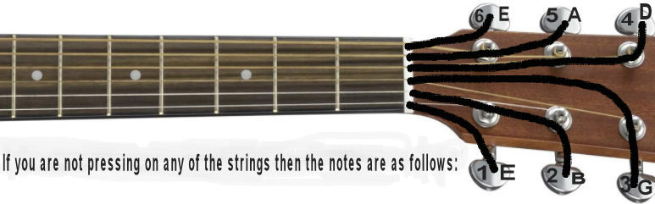
Alright, we're going to look at E is probably one of the most interesting of keys to play, we didn't really look at the key of E. And the reason we did is, the E is easy enough to play, you can look at your quarter chart, quarter chart to play it, it has E, which is a new chord, | 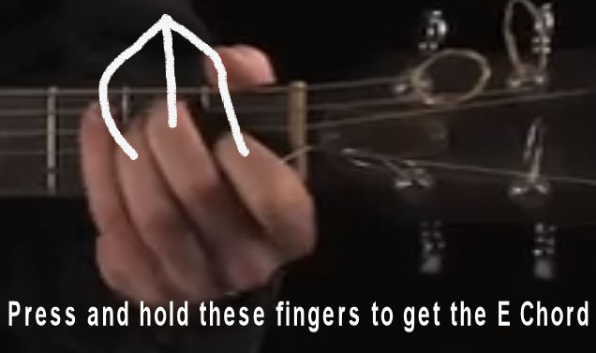
and then it has A which is an old chord. | 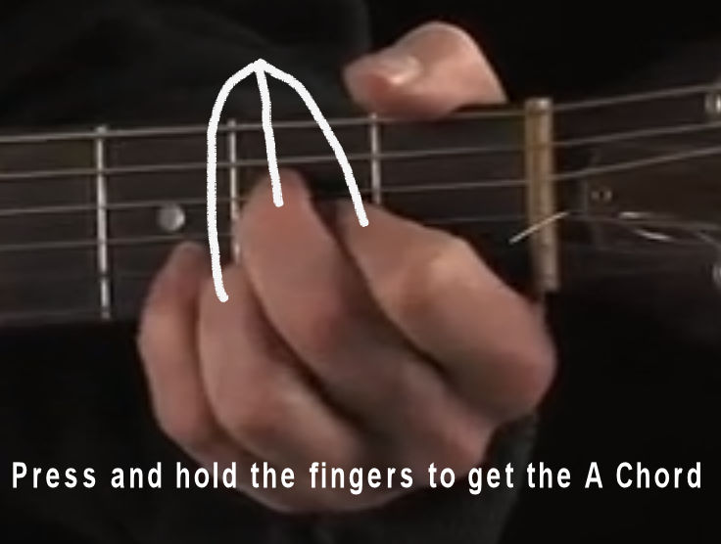
But then it has a B, and B, you can play it this way. Sound not that good because you're not playing these two top strings. | 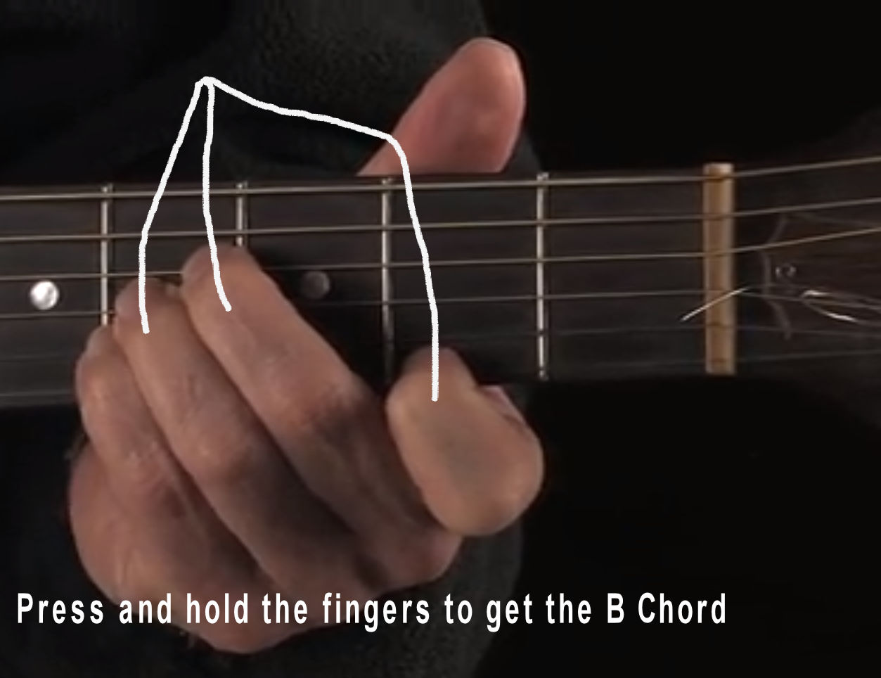
So whenever I play a B, I play way up here, I play a bar chord. But that, you know, sort of an advanced thing to to play a bar chord, you have to hold all these strings down with one finger. And people have a hard time doing that | 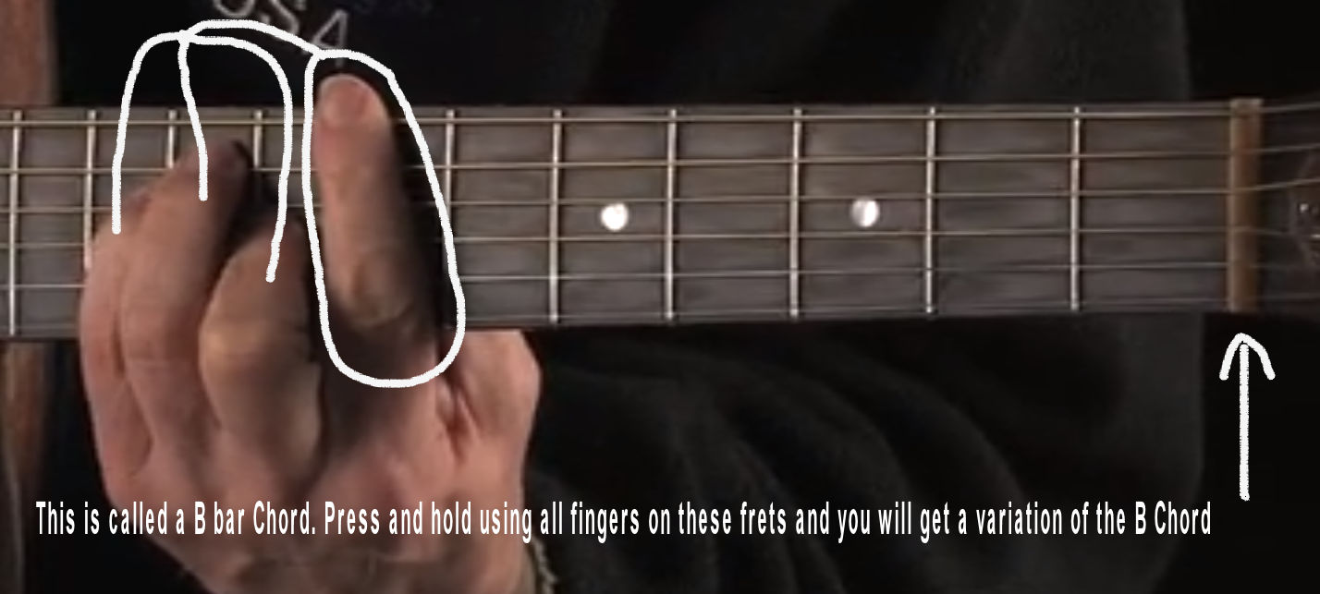
the simplest way to play a B is a version of a B, that's really a B7. And it looks a little complicated, because you're using all four of your fingers. But once you learn it, it's really not that hard. So If you're gonna play in the key of E.  Just used B7, it's a whole lot easier, the key of E has a lot of interesting things to it. First of all, just do a few variations of this basic E chord. There's E, | 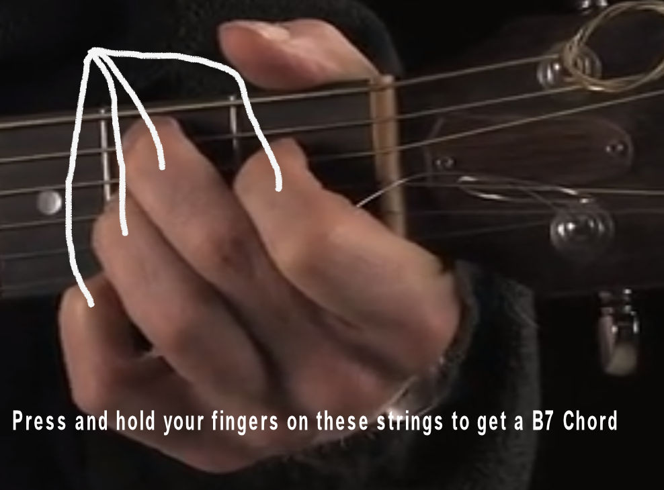
and then there's sustained E. | 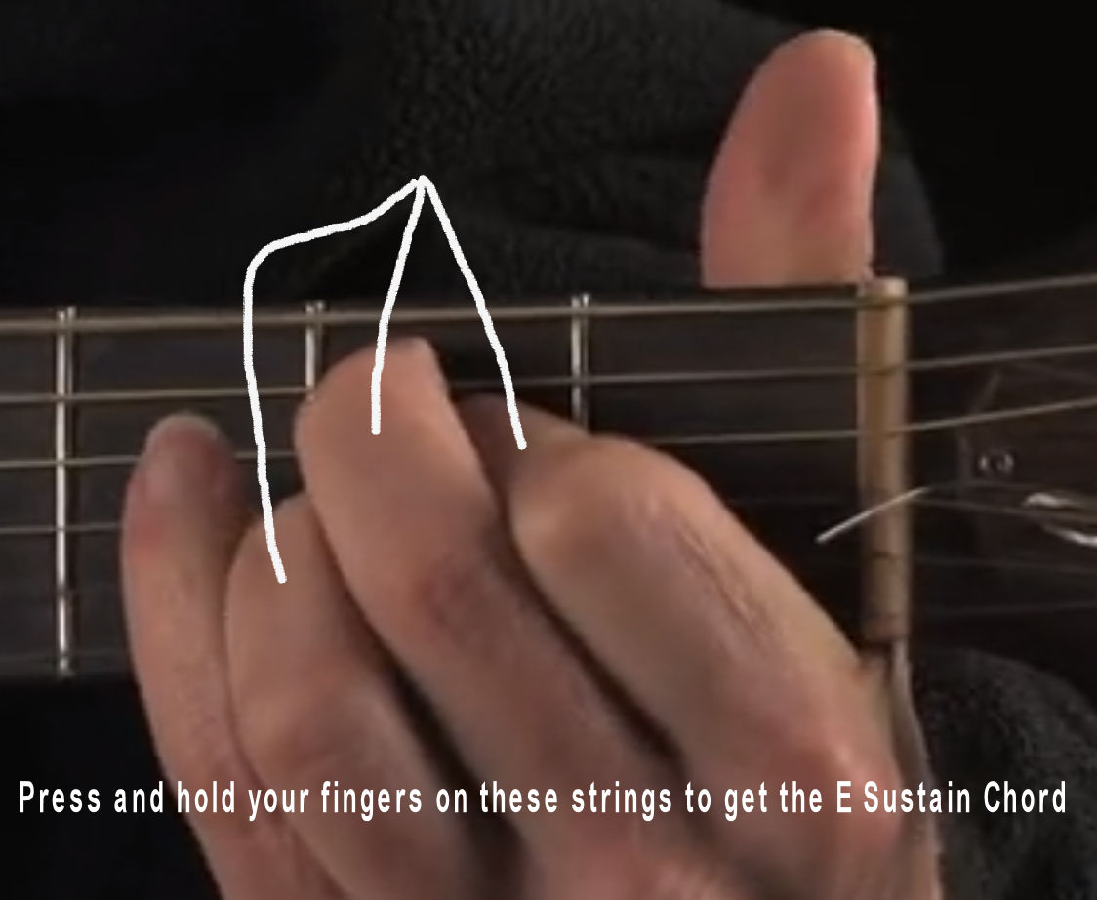
You're playing an E then you play an E7 that wants to go to an A. And it's just like that G to a G7, it wants to resolve. So those are kind of the basic things. | 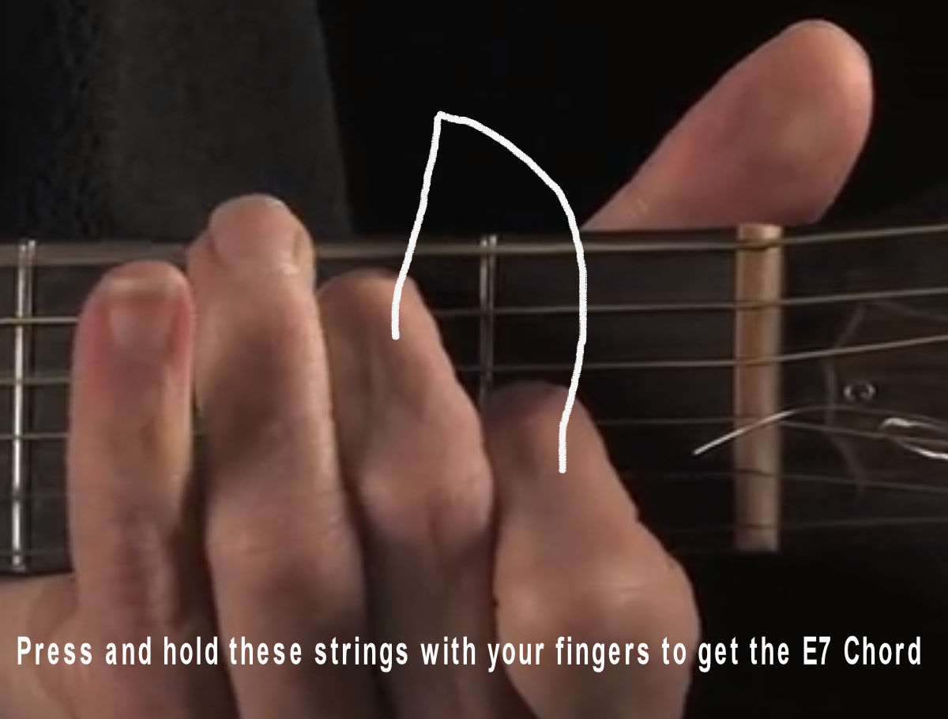
And then there's E minor, | 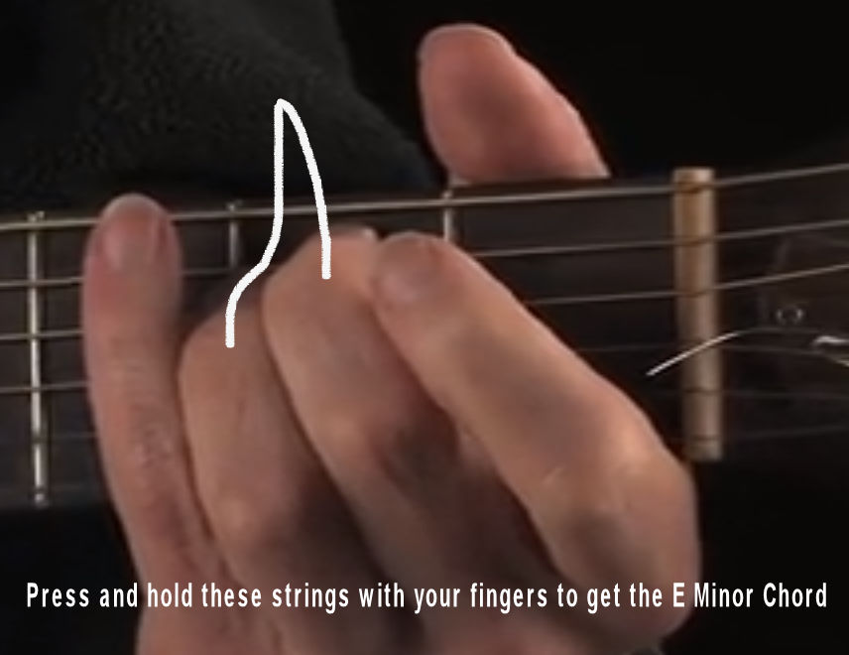
E major, E minor, E major, E minor,  (This is an E Chord but it is also an E Major. Whenever you play a "major chord" the word "major" is the most common so we do not need to say it every time.) | 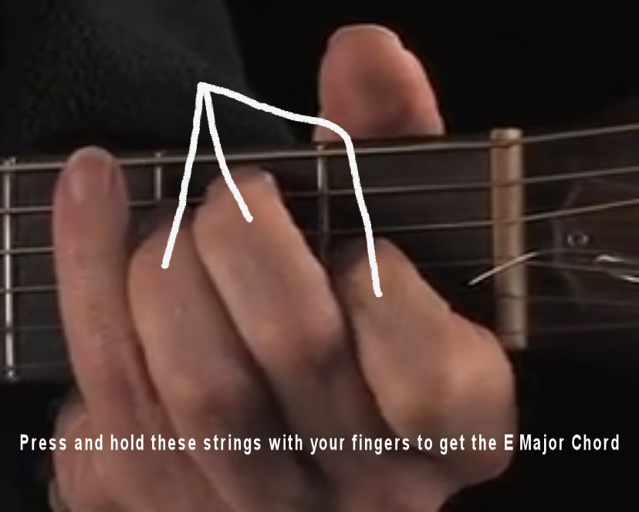
E sustain and E7. Those are kind of the basic ones of E. But the fun part about E is it's also a sound shape. In the intro, I talked about how you can learn one chord and
just move them up and down the neck in place several other records, so that that's true with E you can play this E. Then you can go all the way up. You see these dots. So here's the first, here's the second that so it's one fret above the second dot, sixth fret, I am just playing the same thing as down here, I'm just sliding it right up here. Maybe go two more frets. So this is, in a way, this is a form of an A, you're playing an E you're playing way up here. It's like an A but it's not quite an A. it has a different, more modern sound to it. | 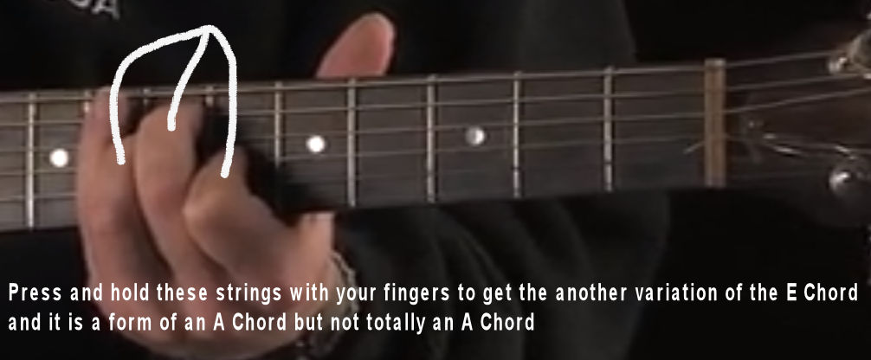
way up here is kind of a B. | 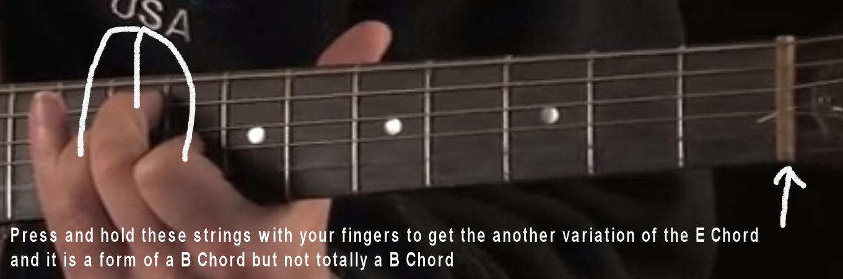
Here's a regular B.
Ways that you know if you really wanted to teach someone the guitar really fast, they could just learn one fingering and go up and down the neck. I could teach someone how to play the guitar in five minutes. Probably not very well. They can learn it. So that's one shape, this is an E that you can take up and down the neck.

