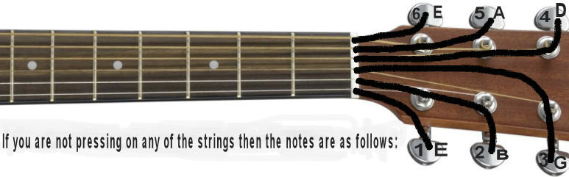
Alright, we're going to look at the G chord. This is the basic G chord. G is really nice because you're strumming all 6 strings and its big and full. | 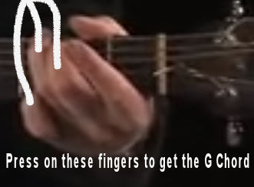
And we want to sustain it, you just take your pointer finger that is G sustain. | 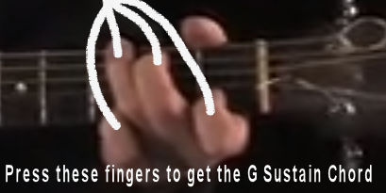
This is G seven. So for example, (singing and strumming) You go from a G to a G seven. what that seven does is it sort of makes you It makes the song want to go to the next chord. So when we are at the G sitting there, when you go to the seventh, he wants to go to the C. So it's it's the Songwriters that they use it to sort of create a little bit movement. It's like we're in the chorus now, but now we got to move you got to go somewhere. wants to resolve at the C. So that's the G seven. | 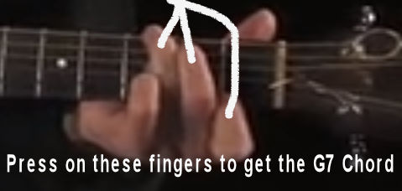
And then I showed this G this sort of fun G when we looked at the C2 remember, C2. Here's the G2 that goes with it. | 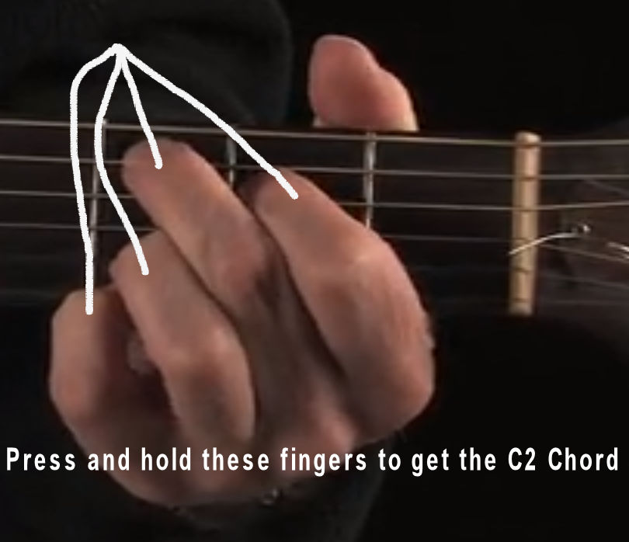 | 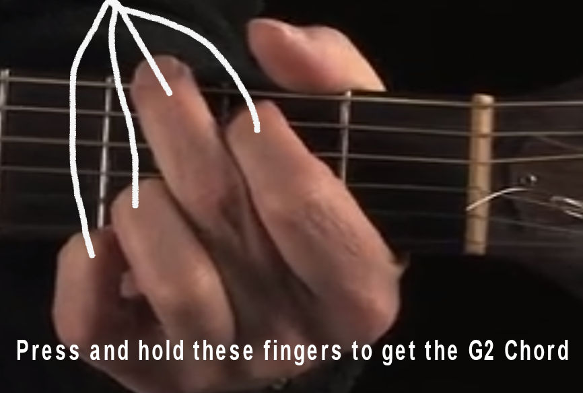
Here's a regular G. But here's this fun G2 a little color to it. A lot of people when they start writing songs, this is one when they discovered a thing. That's basically G.

