The Fire Rescue - The Reconciliation Triangle
Scripture references: Matt. 18:12-14; Romans 12:18
1. Rescuing a relationship from a Conflict Wildfire is like pursuing a lost sheep. Matt. 18:12-14
2. The Reconciliation Triangle identifies the three primary features of relationship reconciliation.
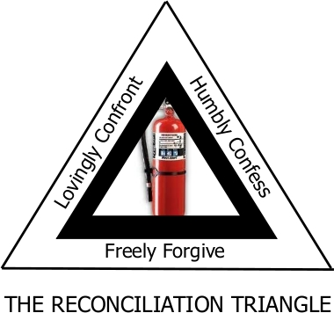
3. The Battle between the flesh and the Spirit can be encountered at any stage of the reconciliation process.
4. The fire rescue is not a formula that guarantees reconciliation if the steps are properly followed.
5. The goal at every stage of confrontation is the pursuit of reconciliation, the loving pursuit of lost sheep and not the pursuit of our own agenda or desired outcome. Romans 12:18
6. Resolving material issues does not always lead to reconciliation, but the reconciliation of relationship (loving one another) accelerates the resolution of material issues.
7. Regardless of how others respond, we will experience the Lord’s peace when we remain in God’s love and treat others the way the Father has treated us in Jesus Christ - with grace, truth, and mercy.

