A Punnett Square Approach to a Monohybrid Cross
KEY POINTS
- Fertilization between two true-breeding parents that differ in only one characteristic is called a monohybrid cross.
- For a monohybrid cross of two true-breeding parents, each parent contributes one type of allele resulting in all of the offspring with the same genotype.
- A test cross is a way to determine whether an organism that expressed a dominant trait was a heterozygote or a homozygote.
VOCABULARY
- Heterozygous: an organism which has two different alleles of a given gene
- Monohybrid: a hybrid between two species that only have a difference of one gene
- Punnett Square: a graphical representation used to determine the probability of an offspring expressing a particular genotype
- Homozygous: an organism in which both copies of a given gene have the same allele

When fertilization occurs between two true-breeding parents that differ in only one characteristic, the process is called a monohybrid cross, and the resulting offspring are monohybrids. Mendel performed seven monohybrid crosses involving contrasting traits for each characteristic. On the basis of his results in F₁ and F₂ generations, Mendel postulated that each parent in the monohybrid cross contributed one of two paired unit factors to each offspring and that every possible combination of unit factors was equally likely.
To demonstrate a monohybrid cross, consider the case of true-breeding pea plants with yellow versus green pea seeds. The dominant seed color is yellow; therefore, the parental genotypes were YY (homozygous dominant) for the plants with yellow seeds and yy (homozygous recessive) for the plants with green seeds, respectively. A Punnett square, devised by the British geneticist Reginald Punnett, can be drawn that applies the rules of probability to predict the possible outcomes of a genetic cross or mating and their expected frequencies.To prepare a Punnett square, all possible combinations of the parental alleles are listed along the top (for one parent) and side (for the other parent) of a grid, representing their meiotic segregation into haploid gametes . Then the combinations of egg and sperm are made in the boxes in the table to show which alleles are combining. Each box then represents the diploid genotype of a zygote, or fertilized egg, that could result from this mating. Because each possibility is equally likely, genotypic ratios can be determined from a Punnett square. If the pattern of inheritance (dominant or recessive) is known, the phenotypic ratios can be inferred as well. For a monohybrid cross of two true-breeding parents, each parent contributes one type of allele. In this case, only one genotype is possible. All offspring are Yy and have yellow seeds.
A self-cross of one of the Yy heterozygous offspring can be represented in a 2 × 2 Punnett square because each parent can donate one of two different alleles. Therefore, the offspring can potentially have one of four allele combinations: YY, Yy, yY, or yy. Notice that there are two ways to obtain the Yy genotype: a Y from the egg and a y from the sperm, or a y from the egg and a Y from the sperm. Both of these possibilities must be counted. Recall that Mendel's pea-plant characteristics behaved in the same way in reciprocal crosses. Therefore, the two possible heterozygous combinations produce offspring that are genotypically and phenotypically identical despite their dominant and recessive alleles deriving from different parents. They are grouped together. Because fertilization is a random event, we expect each combination to be equally likely and for the offspring to exhibit a ratio of YY:Yy:yy genotypes of 1:2:1. Furthermore, because the YY and Yy offspring have yellow seeds and are phenotypically identical, applying the sum rule of probability, we expect the offspring to exhibit a phenotypic ratio of 3 yellow:1 green. Indeed, working with large sample sizes, Mendel observed approximately this ratio in every F₂ generation resulting from crosses for individual traits.
Beyond predicting the offspring of a cross between known homozygous or heterozygous parents, Mendel also developed a way to determine whether an organism that expressed a dominant trait was a heterozygote or a homozygote. Called the test cross , this technique is still used by plant and animal breeders. In a test cross, the dominant-expressing organism is crossed with an organism that is homozygous recessive for the same characteristic. If the dominant-expressing organism is a homozygote, then all F₁ offspring will be heterozygotes expressing the dominant trait. Alternatively, if the dominant expressing organism is a heterozygote, the F₁ offspring will exhibit a 1:1 ratio of heterozygotes and recessive homozygotes. The test cross further validates Mendel's postulate that pairs of unit factors segregate equally.

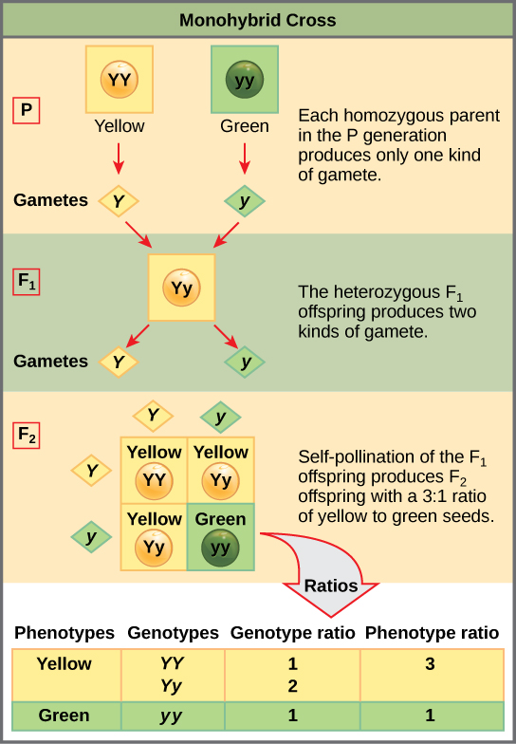 In the P generation, pea plants that are true-breeding for the dominant yellow phenotype are crossed with plants with the recessive green phenotype. This cross produces F1 heterozygotes with a yellow phenotype. Punnett square analysis can be used to predict the genotypes of the F2 generation.
