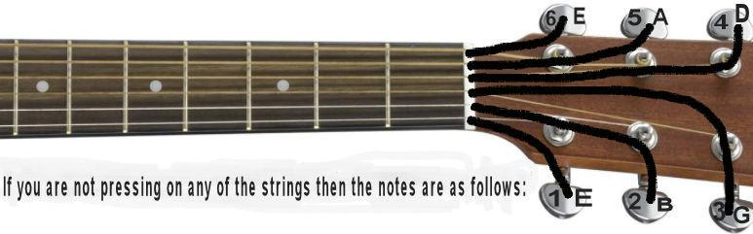

Alright, we're going to learn different things in the for the chord A, your basic A that you are already learned, | 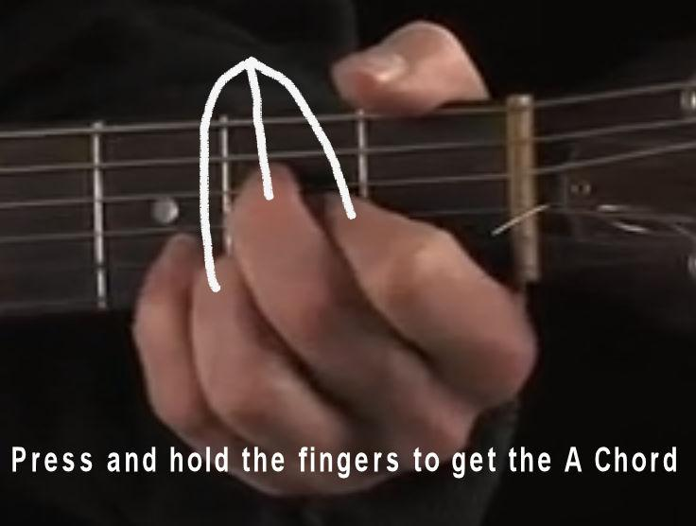
the way to play A seven is to just lift the middle finger. So here's A, A seven. | 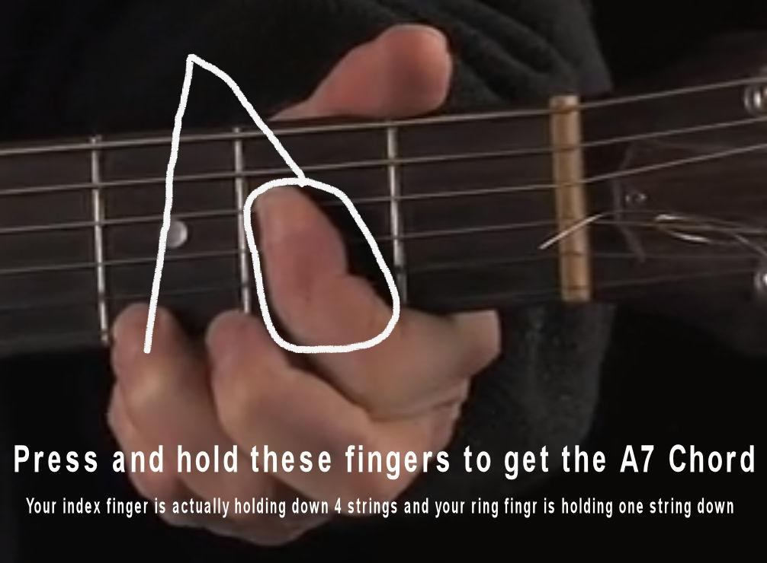
Here's back to A sometime you want to play sustained note. And the way to play that is to put your pinky down the second string here, third fret up. So that song is playing before A sustained so it's a D and it's got that D with the F sharp and the bass so here is a G and there is our A sustain, to an A, back to D over G. Just makes it little more interesting. So there's your A sustain. | 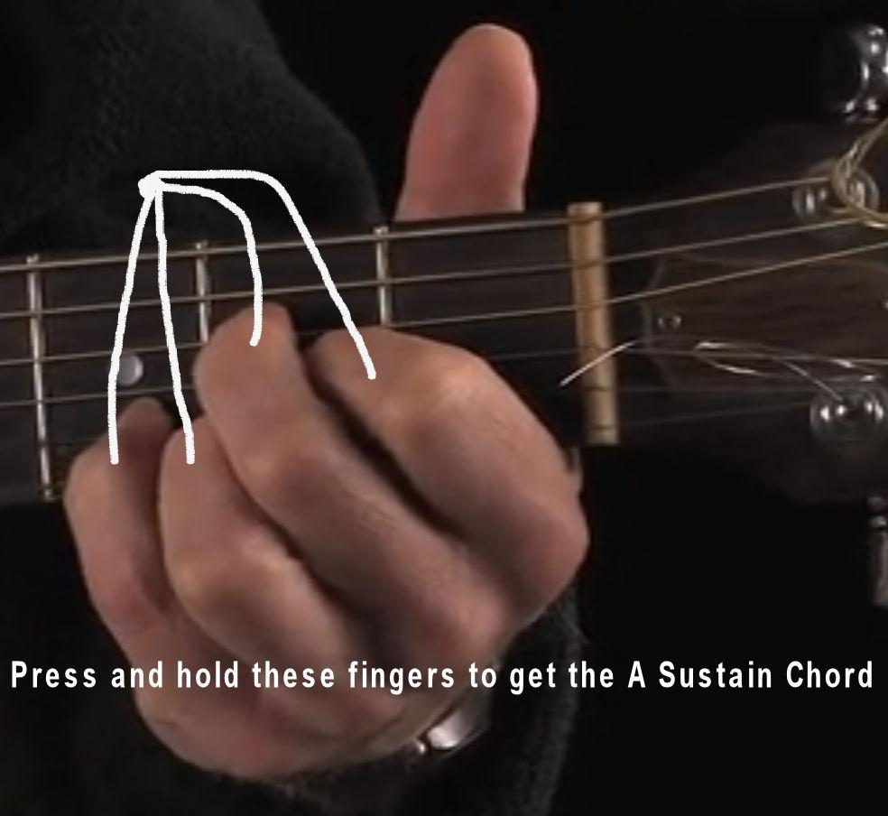
And then we have another A7 played, all you just put all these strings down with one finger.
And then finally, another A2 or an A2 play way up here is an A is an A two. That just gives it a different kind of sound. I wrote a song that starts with this, it's just a different kind of in A down here. It goes to a D2 get these. You know these, these are the basic chords you've already learned. They're just a little bit tweaked. They just sound a whole lot more interesting. So that's that's the A chord. | 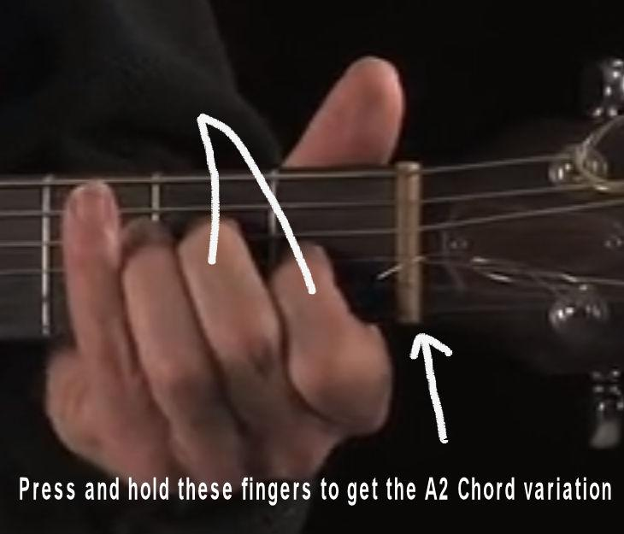 | 