III. RELYING ON GOD’S POWER CHANGES YOUR POSSIBILITIES
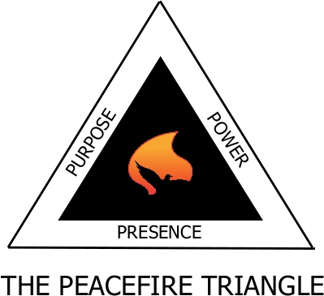
Strange Fire
Scripture references: Lev. 10:1-2; Gen. 4:3-7; Acts 5
1. Strange Fire is an attempt to do the Lord’s will in a manner that He has not approved or authorized. Lev. 10:1-2; Gen. 4:3-7; Acts 5
2. In conflict, Strange Fire means coming to the Peacefire with your own agenda and asking the Lord to bless it rather than humbling yourself, seeking the Lord, and asking that He use you to fulfill His agenda.
3. Strange Fire represents the attempt to resolve conflict in some way other than relentless reliance on Jesus Christ.
4. Strange Fire focuses on bringing an end to the conflict by pursuing an acceptable outcome (win-win scenarios - a cease fire) that does not bring reconciliation and/or glorify Jesus Christ.

