Prokaryotic vs Eukaryotic Gene Regulation
To understand how gene expression is regulated, we must first understand how a gene codes for a functional protein in a cell. The process occurs in both prokaryotic and eukaryotic cells, just in slightly different manners.
Prokaryotic organisms are single-celled organisms that lack a defined nucleus; therefore, their DNA floats freely within the cell cytoplasm. To synthesize a protein, the processes of transcription (DNA to RNA) and translation (RNA to protein) occur almost simultaneously. When the resulting protein is no longer needed, transcription stops. Thus, the regulation of transcription is the primary method to control what type of protein and how much of each protein is expressed in a prokaryotic cell. All of the subsequent steps occur automatically. When more protein is required, more transcription occurs. Therefore, in prokaryotic cells, the control of gene expression is mostly at the transcriptional level.
Eukaryotic cells, in contrast, have intracellular organelles that add to their complexity. In eukaryotic cells, the DNA is contained inside the cell's nucleus where it is transcribed into RNA. The newly-synthesized RNA is then transported out of the nucleus into the cytoplasm where ribosomes translate the RNA into protein. The processes of transcription and translation are physically separated by the nuclear membrane; transcription occurs only within the nucleus, and translation occurs only outside the nucleus within the cytoplasm. The regulation of gene expression can occur at all stages of the process . Regulation may occur when the DNA is uncoiled and loosened from nucleosomes to bind transcription factors (epigenetics), when the RNA is transcribed (transcriptional level), when the RNA is processed and exported to the cytoplasm after it is transcribed (post-transcriptional level), when the RNA is translated into protein (translational level), or after the protein has been made (post-translational level).
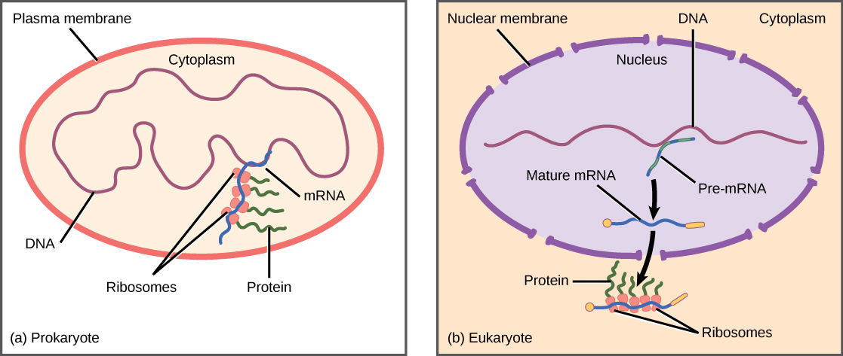

Prokaryotic Gene Regulation – the lac operon and the trp operon
The trp Operon: A Repressor Operon
Bacteria such as E. coli need amino acids to survive. Tryptophan is one such amino acid that E. coli can ingest from the environment. E. coli can also synthesize tryptophan using enzymes that are encoded by five genes. These five genes are next to each other in what is called the tryptophan (trp) operon . If tryptophan is present in the environment, then E. coli does not need to synthesize it; the switch controlling the activation of the genes in the trp operon is turned off. However, when tryptophan availability is low, the switch controlling the operon is turned on, transcription is initiated, the genes are expressed, and tryptophan is synthesized.
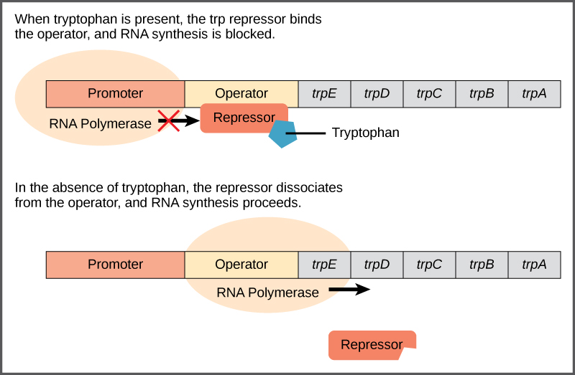
A DNA sequence that codes for proteins is referred to as the coding region. The five coding regions for the tryptophan biosynthesis enzymes are arranged sequentially on the chromosome in the operon. Just before the coding region is the transcriptional start site. This is the region of DNA to which RNA polymerase binds to initiate transcription. The promoter sequence is upstream of the transcriptional start site. Each operon has a sequence within or near the promoter to which proteins (activators or repressors) can bind and regulate transcription.
A DNA sequence called the operator sequence is encoded between the promoter region and the first trp-coding gene. This operator contains the DNA code to which the repressor protein can bind. When tryptophan is present in the cell, two tryptophan molecules bind to the trp repressor, which changes shape to bind to the trp operator. Binding of the tryptophan–repressor complex at the operator physically prevents the RNA polymerase from binding and transcribing the downstream genes.
When tryptophan is not present in the cell, the repressor by itself does not bind to the operator; therefore, the operon is active and tryptophan is synthesized. Because the repressor protein actively binds to the operator to keep the genes turned off, the trp operon is negatively regulated and the proteins that bind to the operator to silence trp expression are negative regulators.
The lac operon is an inducible operon that utilizes lactose as an energy source and is activated when glucose is low and lactose is present.
The lac Operon: An Inducer Operon
A major type of gene regulation that occurs in prokaryotic cells utilizes and occurs through inducible operons. Inducible operons have proteins that can bind to either activate or repress transcription depending on the local environment and the needs of the cell. The lac operon is a typical inducible operon. As mentioned previously, E. coli is able to use other sugars as energy sources when glucose concentrations are low. To do so, the cAMP–CAP protein complex serves as a positive regulator to induce transcription. One such sugar source is lactose. The lac operon encodes the genes necessary to acquire and process the lactose from the local environment, which includes the structural genes lacZ, lacY, and lacA. lacZ encodes β-galactosidase (LacZ), an intracellular enzyme that cleaves the disaccharide lactose into glucose and galactose. lacY encodes β-galactoside permease (LacY), a membrane-bound transport protein that pumps lactose into the cell. lacA encodes β-galactoside transacetylase (LacA), an enzyme that transfers an acetyl group from acetyl-CoA to β-galactosides. Only lacZ and lacY appear to be necessary for lactose catabolism.
CAP binds to the operator sequence upstream of the promoter that initiates transcription of the lac operon. The lac operon uses a two-part control mechanism to ensure that the cell expends energy producing β-galactosidase, β-galactoside permease, and thiogalactoside transacetylase (also known as galactoside O-acetyltransferase) only when necessary. However, for the lac operon to be activated, two conditions must be met. First, the level of glucose must be very low or non-existent. Second, lactose must be present. If glucose is absent, then CAP can bind to the operator sequence to activate transcription. If lactose is absent, then the repressor binds to the operator to prevent transcription. If either of these requirements is met, then transcription remains off. The cell can use lactose as an energy source by producing the enzyme b-galactosidase to digest that lactose into glucose and galactose. Only when both conditions are satisfied is the lac operon transcribed, such as when glucose is absent and lactose is present . This process is beneficial and makes most sense for the cell as it would be energetically wasteful to create the proteins to process lactose if glucose were plentiful or if lactose were not available.
Vocab:
epigenetics: the study of heritable changes caused by the activation and deactivation of genes without any change in DNA sequence
operator: a segment of DNA to which a transcription factor protein binds
operon: a unit of genetic material that functions in a coordinated manner by means of an operator, a promoter, and structural genes that are transcribed together
promoter: the section of DNA that controls the initiation of RNA transcription
repressor: any protein that binds to DNA and thus regulates the expression of genes by decreasing the rate of transcription
RNA polymerase: a DNA-dependent RNA polymerase, an enzyme, that produces RNA

Source:
Source: Boundless. “Prokaryotic versus Eukaryotic Gene Expression.” Boundless Biology. Boundless, 23 Apr. 2015. Retrieved 26 May. 2015 from https://www.boundless.com/biology/textbooks/boundless-biology-textbook/gene-expression-16/regulation-of-gene-expression-111/prokaryotic-versus-eukaryotic-gene-expression-453-11678/
Source: Boundless. “The trp Operon: A Repressor Operon.” Boundless Biology. Boundless, 03 Jul. 2014. Retrieved 26 May. 2015 from https://www.boundless.com/biology/textbooks/boundless-biology-textbook/gene-expression-16/prokaryotic-gene-regulation-112/the-trp-operon-a-repressor-operon-454-11679/
Source: Boundless. “The lac Operon: An Inducer Operon.” Boundless Biology. Boundless, 03 Jul. 2014. Retrieved 26 May. 2015 from https://www.boundless.com/biology/textbooks/boundless-biology-textbook/gene-expression-16/prokaryotic-gene-regulation-112/the-lac-operon-an-inducer-operon-456-11681/

