Fungi cell structure and function
Key Points
- Fungal cell walls are rigid and contain complex polysaccharides called chitin (adds structural strength) and glucans.
- Ergosterol is the steroid molecule in the cell membranes that replaces the cholesterol found in animal cell membranes.
- Fungi can be unicellular, multicellular, or dimorphic, which is when the fungi is unicellular or multicellular depending on environmental conditions.
- Fungi in the morphological vegetative stage consist of a tangle of slender, thread-like hyphae, whereas the reproductive stage is usually more obvious.
- Fungi like to be in a moist and slightly acidic environment; they can grow with or without light or oxygen.
- Fungi are saprophyte heterotrophs in that they use dead or decomposing organic matter as a source of carbon.
Key Terms
- Saprophyte: organism that lives on dead organic matter, as certain fungi and bacteria
- Septum: cell wall division between hyphae of a fungus
- Hypha: a long, branching, filamentous structure of a fungus that is the main mode of vegetative growth
- Mycelium: the vegetative part of any fungus, consisting of a mass of branching, threadlike hyphae, often underground
- Chitin: a complex polysaccharide, a polymer of N-acetylglucosamine, found in the exoskeletons of arthropods and in the cell walls of fungi; thought to be responsible for some forms of asthma in humans
Cell Structure and Function
Fungi are eukaryotes and have a complex cellular organization. As eukaryotes, fungal cells contain a membrane-bound nucleus where the DNA is wrapped around histone proteins. A few types of fungi have structures comparable to bacterial plasmids (loops of DNA). Fungal cells also contain mitochondria and a complex system of internal membranes, including the endoplasmic reticulum and Golgi apparatus.
Unlike plant cells, fungal cells do not have chloroplasts or chlorophyll. Many fungi display bright colors arising from other cellular pigments, ranging from red to green to black. The poisonous Amanita muscaria (fly agaric) is recognizable by its bright red cap with white patches . Pigments in fungi are associated with the cell wall. They play a protective role against ultraviolet radiation and can be toxic.
The rigid layers of fungal cell walls contain complex polysaccharides called chitin and glucans. Chitin, also found in the exoskeleton of insects, gives structural strength to the cell walls of fungi. The wall protects the cell from desiccation and predators. Fungi have plasma membranes similar to other eukaryotes, except that the structure is stabilized by ergosterol: a steroid molecule that replaces the cholesterol found in animal cell membranes. Most members of the kingdom Fungi are nonmotile.
Growth
The vegetative body of a fungus is a unicellular or multicellular thallus. Dimorphic fungi can change from the unicellular to multicellular state depending on environmental conditions. Unicellular fungi are generally referred to as yeasts. Saccharomyces cerevisiae (baker's yeast) and Candida species (the agents of thrush, a common fungal infection) are examples of unicellular fungi .
Most fungi are multicellular organisms. They display two distinct morphological stages: the vegetative and reproductive. The vegetative stage consists of a tangle of slender thread-like structures called hyphae (singular, hypha), whereas the reproductive stage can be more conspicuous. The mass of hyphae is a mycelium. It can grow on a surface, in soil or decaying material, in a liquid, or even on living tissue. Although individual hyphae must be observed under a microscope, the mycelium of a fungus can be very large, with some species truly being "the fungus humongous." The giant Armillaria solidipes (honey mushroom) is considered the largest organism on Earth, spreading across more than 2,000 acres of underground soil in eastern Oregon; it is estimated to be at least 2,400 years old.
Most fungal hyphae are divided into separate cells by endwalls called septa (singular, septum) ( a, c). In most phyla of fungi, tiny holes in the septa allow for the rapid flow of nutrients and small molecules from cell to cell along the hypha. They are described as perforated septa. The hyphae in bread molds (which belong to the Phylum Zygomycota) are not separated by septa. Instead, they are formed by large cells containing many nuclei, an arrangement described as coenocytic hyphae ( b). Fungi thrive in environments that are moist and slightly acidic; they can grow with or without light.
Nutrition
Like animals, fungi are heterotrophs: they use complex organic compounds as a source of carbon, rather than fix carbon dioxide from the atmosphere as do some bacteria and most plants. In addition, fungi do not fix nitrogen from the atmosphere. Like animals, they must obtain it from their diet. However, unlike most animals, which ingest food and then digest it internally in specialized organs, fungi perform these steps in the reverse order: digestion precedes ingestion. First, exoenzymes are transported out of the hyphae, where they process nutrients in the environment. Then, the smaller molecules produced by this external digestion are absorbed through the large surface area of the mycelium. As with animal cells, the polysaccharide of storage is glycogen rather than the starch found in plants.
Fungi are mostly saprobes (saprophyte is an equivalent term): organisms that derive nutrients from decaying organic matter. They obtain their nutrients from dead or decomposing organic matter, mainly plant material. Fungal exoenzymes are able to break down insoluble polysaccharides, such as the cellulose and lignin of dead wood, into readily-absorbable glucose molecules. The carbon, nitrogen, and other elements are thus released into the environment. Because of their varied metabolic pathways, fungi fulfill an important ecological role and are being investigated as potential tools in bioremediation.
Some fungi are parasitic, infecting either plants or animals. Smut and Dutch elm disease affect plants, whereas athlete's foot and candidiasis (thrush) are medically important fungal infections in humans.
Reproduction
KEY POINTS
- New colonies of fungi can grow from the fragmentation of hyphae.
- During budding, a bulge forms on the side of the cell; the bud ultimately detaches after the nucleus divides mitotically.
- Asexual spores are genetically identical to the parent and may be released either outside or within a special reproductive sac called a sporangium.
- Adverse environmental conditions often cause sexual reproduction in fungi.
- Mycelium can either be homothallic or heterothallic when reproducing sexually.
- Fungal sexual reproduction includes the following three stages: plasmogamy, karyogamy, and gametangia.
Key Terms
- Karyogamy: the fusion of two nuclei within a cell
- Sporangium: a case, capsule, or container in which spores are produced by an organism
- Gametangium: an organ or cell in which gametes are produced that is found in many multicellular protists, algae, fungi, and the gametophytes of plants
- Plasmogamy: stage of sexual reproduction joining the cytoplasm of two parent mycelia without the fusion of nuclei
- Homothallic: male and female reproductive structures are present in the same plant or fungal mycelium
- Spore: a reproductive particle, usually a single cell, released by a fungus, alga, or plant that may germinate into another
Fungi reproduce sexually and/or asexually. Perfect fungi reproduce both sexually and asexually, while imperfect fungi reproduce only asexually (by mitosis).
In both sexual and asexual reproduction, fungi produce spores that disperse from the parent organism by either floating on the wind or hitching a ride on an animal. Fungal spores are smaller and lighter than plant seeds. The giant puffball mushroom bursts open and releases trillions of spores. The huge number of spores released increases the likelihood of landing in an environment that will support growth .
Asexual Reproduction
Fungi reproduce asexually by fragmentation, budding, or producing spores. Fragments of hyphae can grow new colonies. Mycelial fragmentation occurs when a fungal mycelium separates into pieces with each component growing into a separate mycelium. Somatic cells in yeast form buds. During budding (a type of cytokinesis), a bulge forms on the side of the cell, the nucleus divides mitotically, and the bud ultimately detaches itself from the mother cell.
The most common mode of asexual reproduction is through the formation of asexual spores, which are produced by one parent only (through mitosis) and are genetically identical to that parent . Spores allow fungi to expand their distribution and colonize new environments. They may be released from the parent thallus, either outside or within a special reproductive sac called a sporangium.
There are many types of asexual spores. Conidiospores are unicellular or multicellular spores that are released directly from the tip or side of the hypha. Other asexual spores originate in the fragmentation of a hypha to form single cells that are released as spores; some of these have a thick wall surrounding the fragment. Yet others bud off the vegetative parent cell. Sporangiospores are produced in a sporangium .
Sexual Reproduction
Sexual reproduction introduces genetic variation into a population of fungi. In fungi, sexual reproduction often occurs in response to adverse environmental conditions. Two mating types are produced. When both mating types are present in the same mycelium, it is called homothallic, or self-fertile. Heterothallic mycelia require two different, but compatible, mycelia to reproduce sexually.
Although there are many variations in fungal sexual reproduction, all include the following three stages . First, during plasmogamy (literally, "marriage or union of cytoplasm"), two haploid cells fuse, leading to a dikaryotic stage where two haploid nuclei coexist in a single cell. During karyogamy ("nuclear marriage"), the haploid nuclei fuse to form a diploid zygote nucleus. Finally, meiosis takes place in the gametangia (singular, gametangium) organs, in which gametes of different mating types are generated. At this stage, spores are disseminated into the environment.
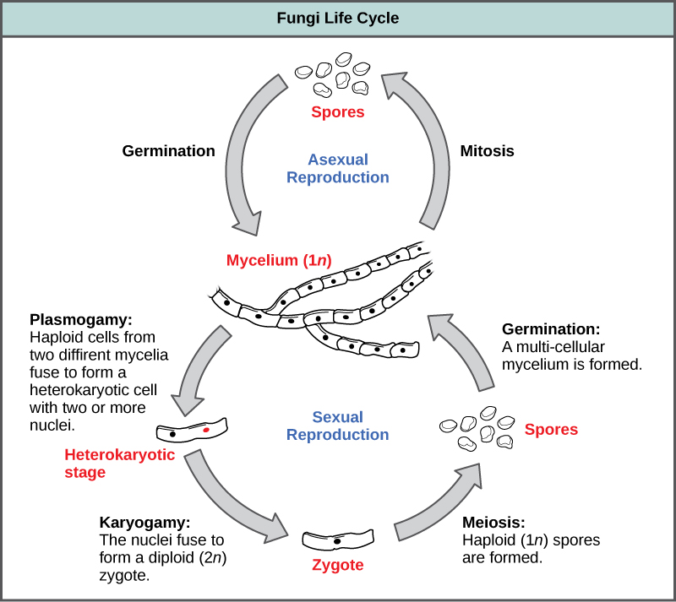

Adapted from
Source: Boundless. “Fungi Cell Structure and Function.” Boundless Biology. Boundless, 12 May. 2015. Retrieved 28 May. 2015 from https://www.boundless.com/biology/textbooks/boundless-biology-textbook/fungi-24/characteristics-of-fungi-149/fungi-cell-structure-and-function-590-11809/
Source: Boundless. “Fungi Reproduction.” Boundless Biology. Boundless, 12 May. 2015. Retrieved 28 May. 2015 from https://www.boundless.com/biology/textbooks/boundless-biology-textbook/fungi-24/characteristics-of-fungi-149/fungi-reproduction-591-11810/

