The Wildfire Triangle
Scripture references: Gal. 5:16-17; 1 John 2:15-16; James 3:13-18; James 4:1-4
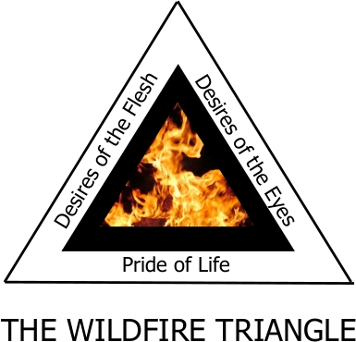
1. Conflict begins in a secret place - the hidden desires of the heart - where the battle between the flesh (world’s kingdom) and the spirit (God’s kingdom) is waged. Galatians 5:16-17
2. The Bible tells us that we cannot love the world and God at the same time. 1 John 2:15-16
3. The Apostle John identified three things that comprise the love of the world: the desires of the flesh, the desires of the eyes, and the pride of life. The Wildfire Triangle illustrates these worldly desires.
4. James wrote about two types of wisdom that motivate the desires of our heart: worldly wisdom and godly wisdom. When our heart is ruled by God’s wisdom, we will sow peace. James 3:13-18.
5. When our heart is ruled by worldly wisdom, we will experience conflict.when we do not get what we desire. James 4:1-4
6. Unmet worldly desires ignite conflict, but conflict reaches Wildfire intensity when someone takes offense.

